**THE ROBOTS ARE HERE. ARE YOU READY TO TAP INTO THE OPPORTUNITY?**

**Global Market Opportunity $ Billion**

|  |  |
| --- | --- |
| **Year** | **Market Size** |
| 2022 | 91.6 |
| 2024 | 118.1 |
| 2026 | 148.3 |
| 2028 | 181.9 |
| 2030 | 237.4 |

**Industrial Robots, the Largest & Traditional Revenue Spinning Sector**

|  |  |
| --- | --- |
| **Robot Type** | **% Share** |
| Industrial Robots | 42.5 |
| Military Robots | 20.1 |
| Healthcare | 13.6 |
| Cleaning Robots | 7.7 |
| Cobots | 2.5 |
| Others | 13.6 |
| **Total** | **100.0** |

**Professional Robots, the Most Popular Type of Service Robots**

|  |  |
| --- | --- |
| **Robot Type** | **% Share** |
| Professional Service Robots | 63.5 |
| Personal Service Robots | 36.5 |
| **Total** | **100.0** |

**Healthcare in the Spotlight With Laparoscopy as a High Growth Application Area**

|  |  |
| --- | --- |
| **Application** | **% Share** |
| Laparoscopy | 34.7 |
| Orthopedic Surgeries | 27.5 |
| Neurosurgeries | 20.2 |
| Other Applications | 17.6 |
| **Total** | **100** |

**Industry Facts & Statistics**

*(present the data in the below given image format and change the icon in the image to the one copied below. Give the figure in the circle)*

**932** robots per 10,000 employees. The figure makes South Korea the most automated country in the world

**1%** increase in robot density can be correlated with productivity increase of 5.1%

**14** million industrial robots are operating globally in 2022

**20** million manufacturing jobs will be replaced by robots by 2030

**9.8** million robotic surgeries have been performed worldwide in the last 10 years

**3,650** AI-powered robots are currently in use worldwide

**20%** is the expected average (2022 to 2030) CAGR of self-healing & muscle-mimicking robots



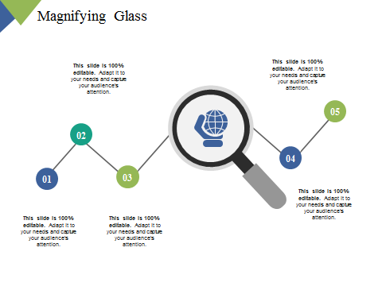

**Trending Market Themes for 2023**

*(Present in below sample image format)*

1. e-Commerce Fuels Boom in Warehouse Robots
2. Smarter, Customized Robots Will Be the New Flavor
3. Cobots to Rise in Popularity
4. Robots Will Become Standard Automation Options
5. Humanoid Robots & Cyber Security
6. Robotics to Boost to EV Revolution
7. Accelerating Democratization of Automation
8. Service Robots to Emerge as the New Growth Frontier
9. Defense Robotics to Hit Prime Time
10. Healthcare to Benefit Most from Robotics



